GYM MANAGEMENT SYSTEM WITH RFID ATTENDANCE INTEGRATION

UNIVERISITI KUALA LUMPUR

GYM MANAGEMENT SYSTEM WITH RFID ATTENDANCE INTEGRATION

Report Submitted to Fulfil the Partial Requirements for the Diploma in Information Technology

Universiti Kuala Lumpur
Malaysian Institute of Information Technology (MIIT

DECLARATION

I declare that this report is my original work and all references have been cited adequately as required by the University.



Name: ADZZEEMIN BIN ADZZAHARI



Name: ABDUL QAYYUM WALDAN BIN MOHAMED RAZIM


Name: AHMAD DANIAL HAKIM BIN AHMAD SHUKRI



Nama: ADAM DARWISH BIN AZLIE

Date: 01/02/2026

APPROVAL PAGE

We have supervised and examined this report and verify that it meets the program and University’s requirements for the Diploma in Information Technology.

Signature:



Name: DR. SITI ZAHARIAH ABDUL WAHAB

Date : 01/02/2026

ACKNOWLEDGEMENT

We would like to express our sincere gratitude to our supervisor,
Dr. Siti Zahariah Abdul Wahab, for her guidance, advice, and continuous support throughout this final year project.

We would also like to thank our lecturers for the knowledge and assistance provided during our studies. Their guidance has helped us to understand and complete this project successfully.

We would also like to acknowledge all those who provided assistance and support during the development of this project.

Contents

DECLARATION i
APPROVAL PAGE 2
ACKNOWLEDGEMENT 1
ABSTRAK (ENGLISH) 4
ABSTRAK (BAHASA MELAYU) 5
CHAPTER 1: INTRODUCTION 1
  - Project Background 1
  - Problem Statement 2
  - Project Objectives 3
  - Project Scope 3
  - Project Significance 4
CHAPTER 2: LITERATURE REVIEW 5
  - Gym Management System 5
  - Attendance Management System 6
  - RFID Technology 6
  - RFID Based Attendance System 7
Summary 7
CHAPTER 3: METHODOLOGY 8
  - Project Methodology 8
. 9
Figure 3.1: Waterfall Development Methodology 9
  - Project Schedule 10
Figure 3.2: Project Schedule 11
  - System Overview 12
  - System Architecture 13
Figure 3.3: System Architecture Diagram 13
  - RFID Attendance Process 14
Figure 3.4: RFID Attendance Process Flow 15
  - Hardware Components 16
  - Software Components 17
  - User Roles 18
  - Summary 18
CHAPTER 4: SYSTEM IMPLEMENTATION AND RESULTS 19
  - System Implementation 19
  - System Interface Design 20
  - RFID Attendance Testing 21
  - User Evaluation Using Google Form 22
  - Summary 23
CHAPTER 5: CONCLUSION AND FUTURE WORK 24
  - Conclusion 24
  - Future Improvements 25
  - Summary 26
REFERENCES 27
APPENDIX 28
Appendix A: Google Form Question 28
Appendix B: Sample Source Code 31

ABSTRAK (ENGLISH)

This project presents the development of a Gym Management System with RFID Attendance Integration. The system is design to improve the efficiency of attendance recording and basic gym management operations for administrators, trainers, and members. In many gyms, attendance is still recorded manually, which can cause delays, errors, and inaccurate records.

The proposed system utilizes Radio Frequency Identification (RFID) technology to automate attendance tracking. Each member and trainer is assigned an RFID card with a unique identifier. When the card is scanned, attendance data is captured and transmitted to a web-based system through an application programming interface (API). The data is then stored in a centralized database for monitoring and reporting purposes.

In addition to attendance tracking, the system provides features such as user management, RFID card registration, attendance history viewing, and membership monitoring. Administrators can manage users and generate attendance reports, trainers can record their attendance and manage assigned members, while members can view their personal attendance records.

Overall, the system helps reduce manual workload, improve data accuracy, and enhance the efficiency of gym operations. This project demonstrates the practical integration of RFID hardware with a web-based system suitable for real-world gym environments.

ABSTRAK (BAHASA MELAYU)

Projek ini membentangkan pembangunan Sistem Pengurusan Gim dengan Integrasi Kehadiran RFID. Sistem ini direka untuk meningkatkan kecekapan perekodan kehadiran dan operasi asas pengurusan gim bagi pentadbir, jurulatih, dan ahli gim. Di kebanyakan gim, kehadiran masih direkodkan secara manual, yang boleh menyebabkan kelewatan, kesilapan, dan rekod yang tidak tepat.

Sistem yang dicadangkan menggunakan teknologi Radio Frequency Identification (RFID) untuk mengautomasikan perekodan kehadiran. Setiap ahli dan jurulatih diberikan kad RFID dengan pengenal unik. Apabila kad diimbas, data kehadiran akan direkodkan dan dihantar ke sistem berasaskan web melalui application programming interface (API). Data ini kemudiannya disimpan di dalam pangkalan data berpusat untuk tujuan pemantauan dan pelaporan.

Selain perekodan kehadiran, sistem ini turut menyediakan fungsi seperti pengurusan pengguna, pendaftaran kad RFID, paparan sejarah kehadiran, dan pemantauan status keahlian. Pentadbir boleh menguruskan pengguna dan menjana laporan kehadiran, jurulatih boleh merekodkan kehadiran serta menguruskan ahli yang ditugaskan, manakala ahli boleh melihat rekod kehadiran peribadi mereka.

Secara keseluruhan, sistem ini dapat mengurangkan beban kerja manual, meningkatkan ketepatan data, dan menambah baik kecekapan operasi gim. Projek ini menunjukkan integrasi praktikal antara perkakasan RFID dan sistem berasaskan web yang sesuai untuk persekitaran gim sebenar.

CHAPTER 1: INTRODUCTION

Project Background

Many gyms, attendance is still record manually using logbooks or basic computer systems. This approach requires staff involvement and may result in long waiting times during peak hours. In addition, manual recording increases the possibility of incorrect or missing data.

The RFID technology provides a reliable and contactless method for identification and attendance tracking. Each RFID card contains a unique identifier that allows users to be identified quickly when scanned. This technology has been widely used in access control and attendance systems due to its efficiency and ease of use.

The proposed system integrates RFID hardware with a web-based application to auto attendance recording for both gym members and trainers. Attendance data is transmitted to the system through an application programming interface (API) and stored in a centralized database for monitoring and reporting purposes.

Problem Statement

Manual attendance systems used in gyms require more time and can result in inaccurate attendance records. Staff are required to manually record attendance, which may cause delay and inconvenience to gym members especially in medium and large sized gyms where the system used is still basic. Without accurate attendance records, gym administrators may face difficulties in tracking member participation and trainer attendance.

Some existing systems only focus on recording member attendance and do not properly record trainer attendance. Without a centralized system, attendance data is difficult to manage and reporting becomes less effective. Manual attendance processes require staff involvement and may slow down daily gym operations, especially during peak hours.This situation can cause inconvenience to both gym staff and gym members during the check in process.

An automated attendance system is needed to improve accuracy, reduce manual workload, and provide better attendance management. In some gyms, trainer attendance is not properly recorded, making it difficult to monitor trainer schedules and assigned sessions. The lack of proper trainer attendance records may affect gym management in planning training sessions and evaluating trainer performance.

Project Objectives

    - To develop a web-based gym management system.
    - To implement RFID technology for automated attendance recording.
    - To record attendance for both gym members and trainers.
    - To improve the efficiency of gym system management operations.

Project Scope

This project focuses on the development of a gym management system with RFID attendance integration. The system is designed for three types of users: administrator, trainer, and member.

The system includes basic functions such as user management, RFID card registration, automated attendance recording, and attendance history viewing. advanced features such as biometric authentication, mobile applications, and advanced data analytics are not included in the scope of this project.

The scope of this project includes the use of RFID technology for attendance recording purposes only.

Project Significance

The proposed system helps make daily gym operations easier by automating attendance recording. With this system, gym staff do not need to record attendance manually, which helps reduce workload and save time during daily operations.

The system also provides a simpler checkin proces for gym members. By using RFID cards, members can record their attendance more quickly, especially during busy hours. This helps reduce waiting time and improves the overall experience for gym members.

For gym management, having attendance data stored in a centralized system makes it easier to monitor attendance records and prepare basic reports. This allows management to manage gym operations more effective.

From an academic perspective, this project gives practical experience in developing a web-based system and integrating RFID technology using Arduino. It also helps the student gain a better understanding of how hardware and software can work together in a real-world application.

CHAPTER 2: LITERATURE REVIEW

Gym Management System

A gym management system is designed to support the daily operations of a gym in an organized manner. It helps gym staff and management handle tasks such as member registration, trainer management, attendance tracking, and membership monitoring. By using a centralized system, information can be stored and accessed more easily compared to manual record keeping.

In many gyms, basic management tasks are still handled manually or using separate systems. This can cause difficulties when staff need to search for member information or check attendance records. A gym management system helps reduce these issues by storing all relevant data in one place, making daily operation more efficient and structured.

Another important function of a gym management system is membership management. The system can be used to monitor membership status such as active or expired memberships.

Gym management systems often include attendance history features. Attendance records can be used to track member visit patterns and trainer presence. This information is useful for monitoring gym usage and supporting basic reporting purposes.

a gym management system helps improve organization, reduce manual work, and support better management of gym operations. These features provide a foundation for integrating automated attendance technologies such as RFID, which is relevant to the development of this project.

Attendance Management System

Attendance management systems are used to record user attendance in places such as schools, offices, and gyms. Traditional attendance systems usually use manual recording, which requires staff involvement and takes more time.

Manual attendance recording can also cause problems such as missing or incorrect records. Automated attendance systems help reduce these issues by recording attendance systematic. This makes it easier to store attendance data and use it for monitoring and basic reporting.

RFID Technology

Radio Frequency Identification (RFID) is a technology used to identify objects or people automatically. An RFID system includes RFID tags, an RFID reader, and a backend system. Each RFID tag has a unique identification number that can be read by the RFID reader.

RFID technology allows information to be read without physical contact. It is simple and fast, which makes it suitable for uses such as attendance recording and access control. RFID is commonly used in places that require quick and easy identification.

RFID Based Attendance System

An RFID based attendance system uses RFID cards to record attendance automatically. When a user scans an RFID card, the system reads the card unique identifier and records the attendance information.

This type of system helps reduce manual work and improves attendance accuracy. RFID based attendance systems are commonly used in places such as gyms, schools, and offices where quick attendance recording is needed.

Summary

At This chapter discussed gym management systems, attendance management systems, RFID technology, and RFID based attendance systems. These systems are commonly used to support daily operations in gyms and other organizations.

The discussion shows that manual attendance systems require more time and effort and may cause errors in attendance records. Automated attendance systems, especially those using RFID technology, help reduce manual work and improve attendance accuracy.

RFID technology provides a simple and fast way to record attendance without physical contact. Due to these advantages, RFID based attendance systems are suitable for gym environments where quick and accurate attendance recording is need.

Overall, the studies reviewed in this chapter support the development of a gym management system with RFID attendance integration, as proposed in this project.

CHAPTER 3: METHODOLOGY

Project Methodology

The project uses a simple and clear approach to develop a gym management system with RFID attendance integration. The main purpose of this methodology is to ensure that the system can be developed properly and works as expected.
The methodology used in this project consists of several phases, which are planning, system design, development, testing, and implementation. Each phase is carried out step by step to avoid confusion and reduce mistakes during development.

During the planning phase, the project objectives and system requirements are identified. This phase helps to understand what the system needs to do and what functions should be included. Clear planning also helps ensure that the project stays on track.

In the system design phase, the overall structure of the system is planned. This includes planning how the hardware and software components will work together. The system design helps provide a clear guide before starting the development process.

After that, the development phase is carried out. During this phase, the system is built based on the planned design. This is followed by the testing phase, where the system is tested to make sure that it works properly and can record attendance correctly. Finally, the implementation phase involves using the system in a real environment. This step-by- step approach helps ensure that the system meets the project objectives.

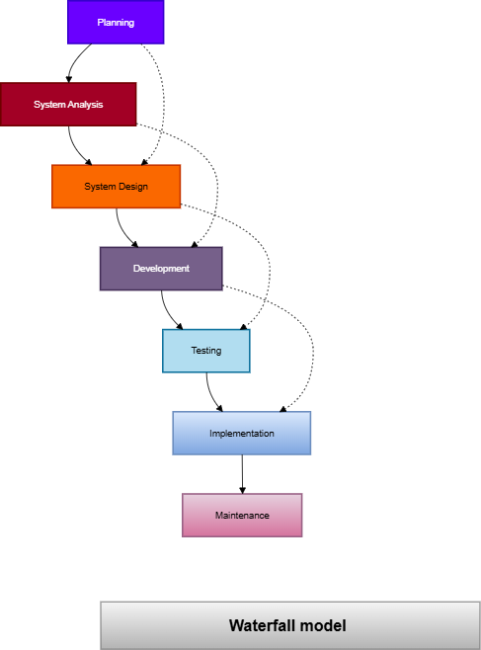

Figure 3.1: Waterfall Development Methodology

Project Schedule

The section below describes the project schedule for developing the gym management system with RFID attendance integration. The project schedule is prepared using a Gantt chart to show the timeline of each project activity.

The schedule includes activities such as planning, system design, hardware setup, system development, testing, documentation, and final submission. The project schedule helps ensure that all tasks are completed within the given time frame.

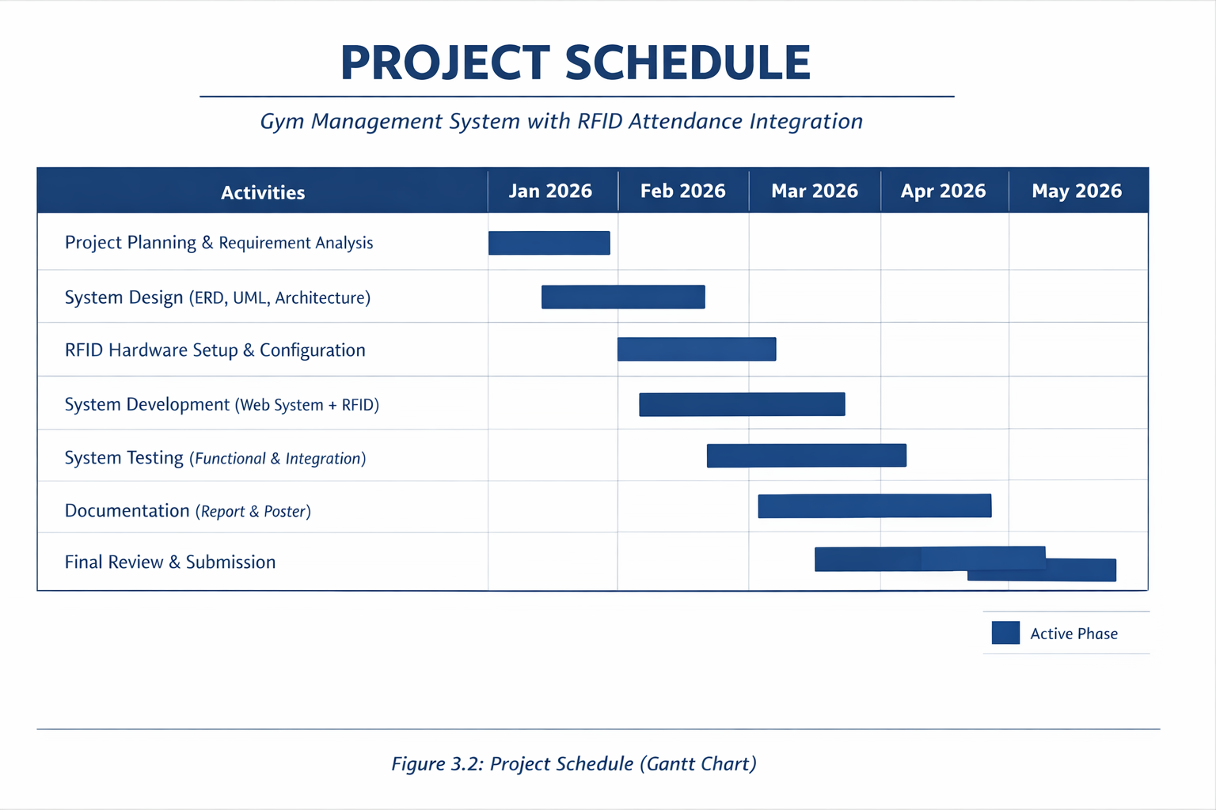

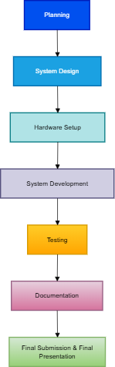

Figure 3.2: Project Schedule

System Overview

The system is designed to record gym attendance automatically using RFID technology. It consists of both hardware and software components that work together.

The main hardware components include RFID cards, an RFID reader, and an Arduino microcontroller. The software components include a web-based system, an API, and a database.

When a user scans an RFID card, the RFID reader reads the card information. The Arduino processes the data and sends it to the web-based system, where the attendance information is stored in the database

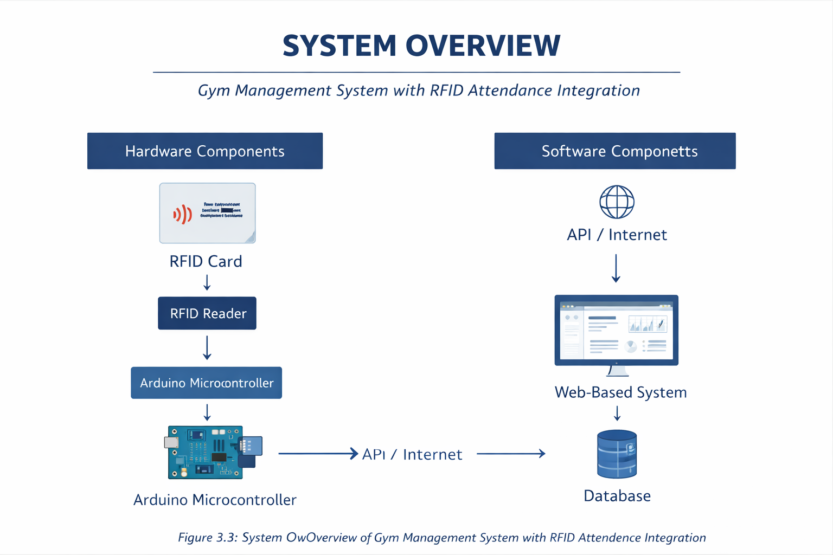

System Architecture

The system architecture of the gym management system with RFID attendance integration. The diagram explains how the hardware and software components are connected.

The process starts when a gym member or trainer scans an RFID card. The RFID reader reads the card data and sends it to the Arduino microcontroller. The Arduino then sends the data to the web-based system through a wifi connection and an API. The system stores the attendance data in the database.

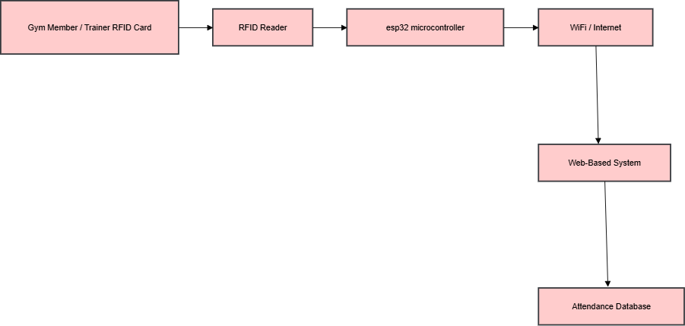

Figure 3.3: System Architecture Diagram

RFID Attendance Process

RFID attendance process flow used in this project. The process begins when a gym member or trainer scans an RFID card at the RFID reader.The RFID reader reads the unique identifier from the card and sends it to the Arduino. The Arduino processes the data and sends it to the web-based system through an API. The system verifies the user and records the attendance details in the database.This process allows attendance to be recorded automatically without manual input.

Start
↓
RFID Card Scanned
↓
RFID Reader Reads Card ID
↓
Arduino Receives & Processes Data
↓
Send Data via API
↓
System Verifies User
↓
Attendance Recorded in Database
↓
End

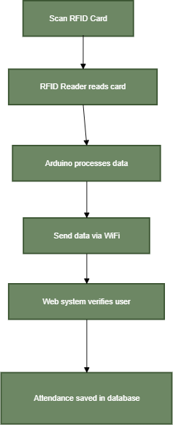

Figure 3.4: RFID Attendance Process Flow

Hardware Components

The hardware components used in this project include RFID cards, an RFID reader, and an Arduino microcontroller. RFID cards are used by gym members and trainers to record attendance.

The RFID reader reads the card information, while the Arduino acts as a controller that processes the data and sends it to the web-based system.

    - RFID Card
Used by gym members and trainers
Each card contains a unique identification number (UID)

    - RFID Reader
Used to read the UID from the RFID card Sends the card data to the microcontroller

    - ESP32 Microcontroller
Acts as the main controller of the system Receives RFID data from the RFID reader
Sends attendance data to the web-based system

    - WiFi / Internet Connection
Used to transmit data from the ESP32 to the web-based system

Software Components

The software components used in this project include a web-based system, an application programming interface (API), and a database system. The web-based system is developed using PHP and runs on a local server using XAMPP.

The database is managed using MySQL and is used to store user information, RFID card details, and attendance records. The API is used to receive RFID data from the Arduino and save the attendance information into the database.

    - Web-Based System
Developed using PHP
Used by administrator, trainer, and member

    - Database Management System MySQL
Used to store user information, RFID UID, and attendance records

    - Local Server
XAMPP
Used to run Apache and MySQL for the web-based system

    - Application Programming Interface (API)
Used to receive RFID data from the ESP32 microcontroller Stores attendance data into the database

    - Development Tool
Sublime Text
Used to write and edit the PHP source code

User Roles

The system supports three main user roles: administrator, trainer, and member. The administrator manages user accounts, assigns RFID cards, and monitors attendance records. Trainers can view attendance related to their sessions. Members can scan RFID cards to record attendance and view their attendance history.

Summary

Chapter 3 explained the methodology used to develop the gym management system with RFID attendance integration. It discussed the project methodology, project schedule, system overview, system architecture, RFID attendance process, hardware components, software components, and user roles. This methodology provides a clear guide for developing and implementing the proposed system.



CHAPTER 4: SYSTEM IMPLEMENTATION AND RESULTS

System Implementation

gym management system with RFID attendance integration is implemented and how the system performs after development. The implementation focuses on combining hardware and software components to support automatic attendance recording in a gym environment.
The system uses an RFID reader that is connected to an ESP32 microcontroller. When a gym member or trainer scans an RFID card, the RFID reader reads the unique identifier stored in the card. The ESP32 then receives this information and processes the data before sending it to the web-based system through a wifi connection using an application programming interface (API).
After the data is received by the web-based system, the system checks whether the RFID card is registered in the database. If the user is valid, attendance details such as user role, date, and time are recorded automatically. All attendance data is stored in a centralized database, allowing gym management to monitor attendance records easily. This implementation reduces the need for manual attendance recording and helps improve daily gym operations.

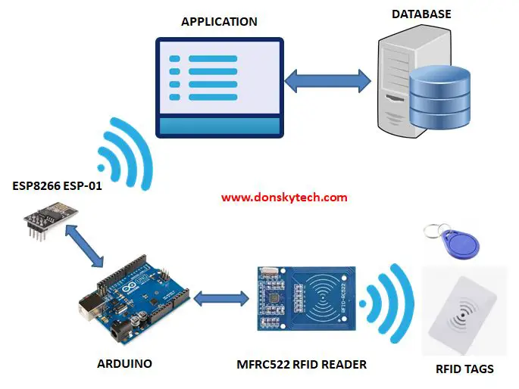

System Interface Design

User interface of the gym management system is presented in this section. The interface is designed to be simple, clear, and easy to understand so that users can use the system without difficulty.

The system includes a login page and an administrator dashboard. The login page allows users to enter their login credentials and access the system based on their assigned roles. The administrator dashboard provides access to important system functions such as managing users, assigning RFID cards, and viewing attendance records.

The interface design focuses on basic functionality rather than advanced design features. This approach ensures that the system is easy to use and suitable for users with different levels of technical knowledge. Clear layout and simple navigation help users perform tasks efficiently.

Figure 4.1: Login Page Interface
Figure 4.2: Administrator Dashboard Interface

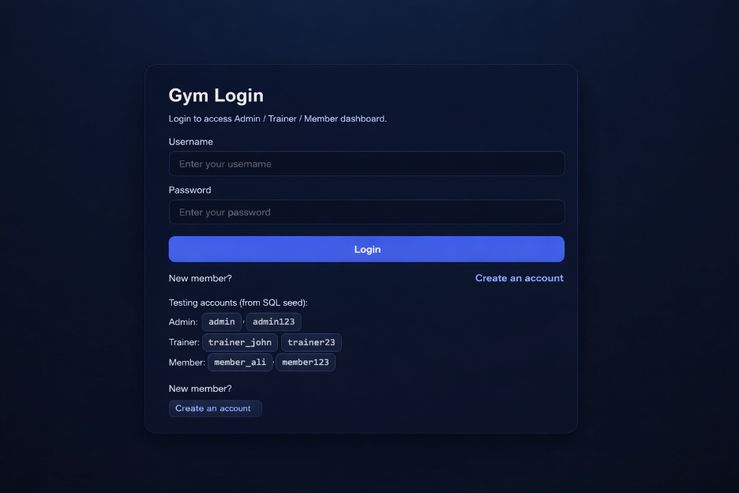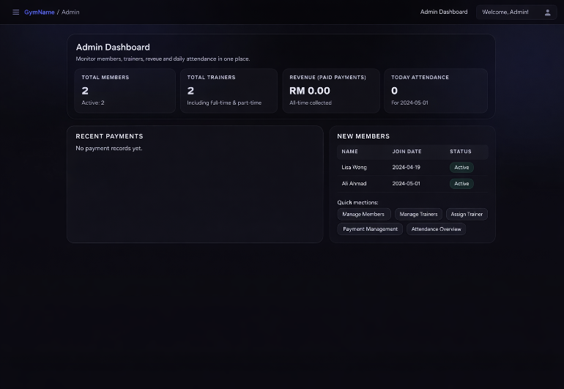

RFID Attendance Testing

RFID attendance testing was conducted to evaluate the functionality and reliability of the system. The testing process focused on ensuring that attendance could be recorded correctly using RFID cards and that data could be stored successfully in the database.

During testing, RFID cards were scanned multiple times using the RFID reader. The ESP32 microcontroller was able to read the RFID data and transmit it to the web-based system without errors. The system successfully recorded attendance details and stored them in the database.

The test results show that the RFID attendance function works properly and consistently. Attendance data was recorded accurately for both gym members and trainers. The testing process confirms that the system is suitable for real-world use in a gym environment.

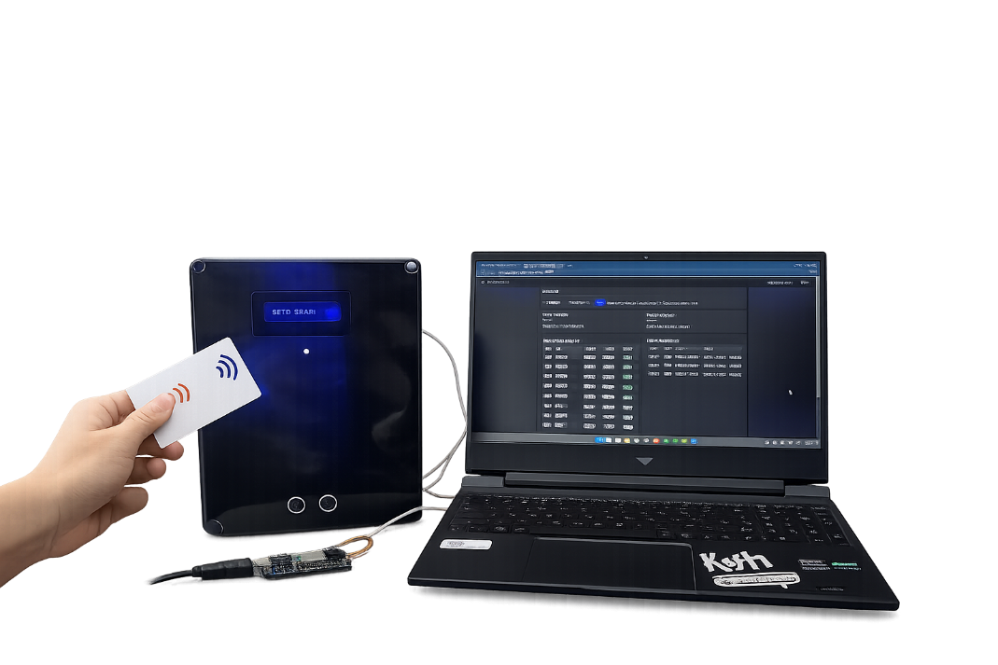

User Evaluation Using Google Form

User evaluation was carried out using Google Form to collect feedback from users who tested the system. The purpose of the evaluation was to understand user opinions on system usability, functionality, and overall performance.

The survey was distributed to users after they interacted with the system. Questions in the survey focused on ease of use, speed of attendance recording, and overall user satisfaction. Most respondents indicated that the system is easy to use and that the RFID attendance process is fast and convenient.

Some users also mentioned that the system helps reduce waiting time during attendance recording, especially during busy hours. The feedback collected shows that the system meets basic user requirements and provides a positive experience for users.

Figure 4.3: User Feedback Results (Google Form)

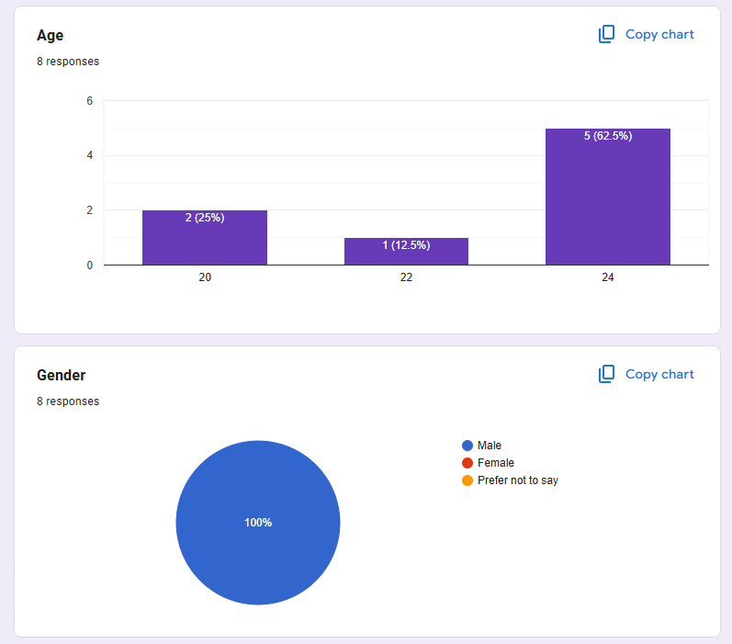
1. easy of use of the RFID Check-in System
Most gym members found the RFID check-in system easy to use.
- 37.5% rated it as Very Easy
- 37.5% rated it as Easy
- 25% rated it as Neutral
- 0% selected Difficult or Very Difficult

This shows that 75% of respondents had a positive experience, indicating the system is generally user-friendly.

2. Reduction in entry time
The majority of members felt that the RFID system reduced the time needed to enter the gym.
- 62.5% said Yes, a lot
- 25% said Yes, a little
- 12.5% said No change
- 0% said it takes longer
This suggests that 87.5% of respondents experienced faster entry, showing the system effectively improves efficiency.

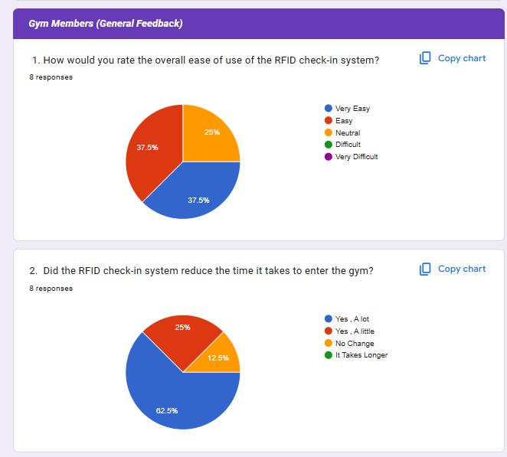
3. Comfort Level in Using the RFID System
Most respondents felt comfortable using the RFID system for gym attendance.
- 62.5% rated it as Very Comfortable
- 37.5% rated it as Comfortable
- 0% selected Neutral, Uncomfortable, or Very Uncomfortable
This shows that 100% of respondents feel comfortable using the system, indicating strong user acceptance and confidence.

4. Accuracy of the RFID System in Tracking Attendance
The majority of members believe the RFID system is accurate in recording attendance.
- 62.5% rated it as Very Accurate
- 25% rated it as Accurate
- 12.5% rated it as Neutral
- 0% selected Inaccurate or Very Inaccurate
This means 87.5% of respondents perceive the system as accurate, suggesting high reliability and trust in the attendance tracking process.

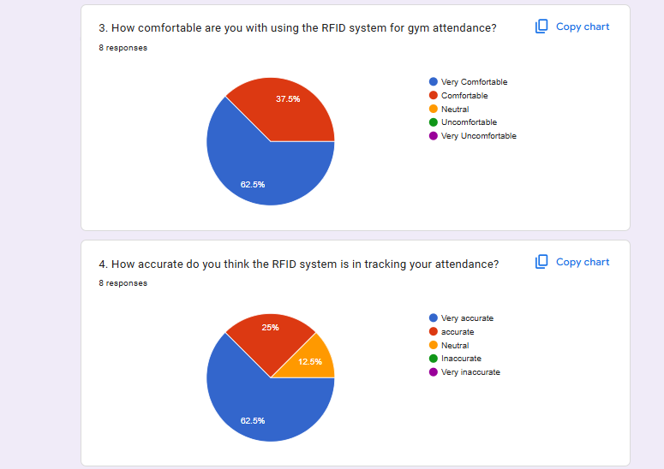

5. Issues with RFID Scanner Not Recognizing Membership
Responses were evenly split regarding issues with the RFID scanner.
- 50% said Yes, frequently
- 50% said No, never
- 0% selected Yes, occasionally

This indicates that while half of the respondents have not experienced any problems, the other half frequently encounter recognition issues. This suggests there may be consistency or technical reliability concerns that need improvement.

6. Security of RFID System Compared to Traditional Check-in Methods
Most respondents believe the RFID system is more secure than traditional methods.
- 87.5% said Yes
- 12.5% selected Neutral
- 0% said No

This shows a strong perception that the RFID system enhances security, increasing trust in the gym’s check-in process.

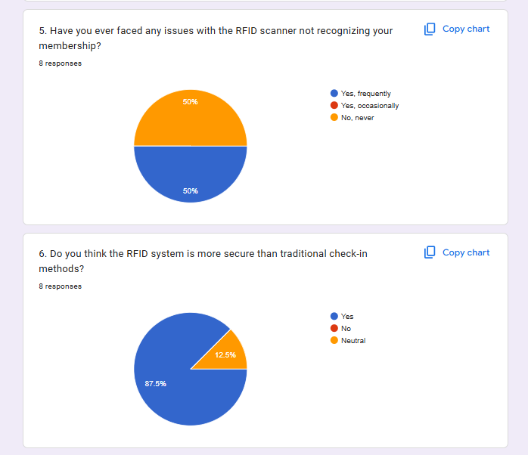
7. Frequency of Using the RFID System
Most members use the RFID system consistently when checking in at the gym.
- 62.5% use it on every visit
- 25% use it on most visits
- 12.5% use it occasionally
- 0% selected Never

This shows that the RFID system is widely adopted and regularly used by members, indicating high reliance on the system.

8. Guidance Received on Using the RFID System
All respondents confirmed that they received clear guidance on how to use the RFID system.
- 100% selected Yes, very clear
- 0% selected other options

This suggests that the gym provided effective instructions, ensuring members understand how to use the system properly.

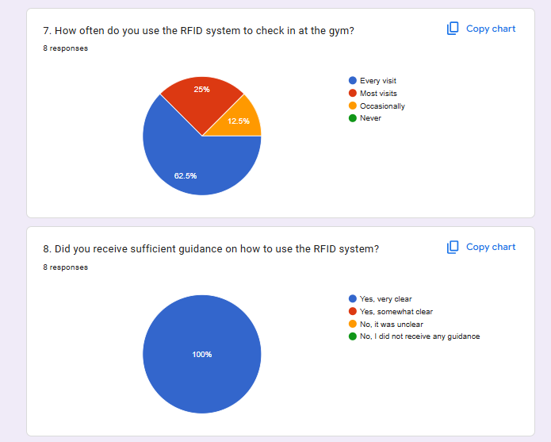

9. Likelihood of Recommending the RFID System
The majority of respondents are highly likely to recommend the RFID check-in system to other gym members.
- 87.5% selected Very likely
- 12.5% selected Likely
- 0% selected Neutral, Unlikely, or Very unlikely

This indicates very strong overall satisfaction with the system, as all respondents are positive about recommending it.

10. Delays During Peak Gym Hours
Responses regarding delays during peak hours were mixed.
- 25% experienced delays frequently
- 25% experienced delays occasionally
- 50% reported no delays

While half of the respondents did not face any delays, the other half experienced some level of delay, suggesting that performance during peak hours could be improved.

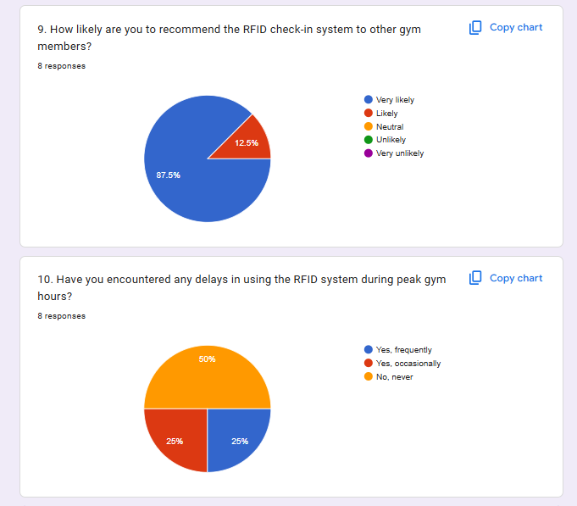

1. Satisfaction with the Speed of the RFID System
Most respondents are satisfied with the speed of the RFID system compared to manual check-ins.
- 50% rated it as Very satisfied
- 37.5% rated it as Satisfied
- 12.5% selected Neutral
- 0% selected Unsatisfied or Very unsatisfied

This shows that 87.5% of respondents are satisfied with the system’s speed, indicating that the RFID system significantly improves check-in efficiency.

2. Convenience Compared to Paper-Based Attendance Tracking
All respondents believe that the RFID system is more convenient than paper-based attendance tracking.
- 62.5% selected Yes, definitely
- 37.5% selected Yes, somewhat
- 0% selected No change or Less convenient

This indicates 100% positive feedback regarding convenience, suggesting that members strongly prefer the RFID system over traditional paper methods.

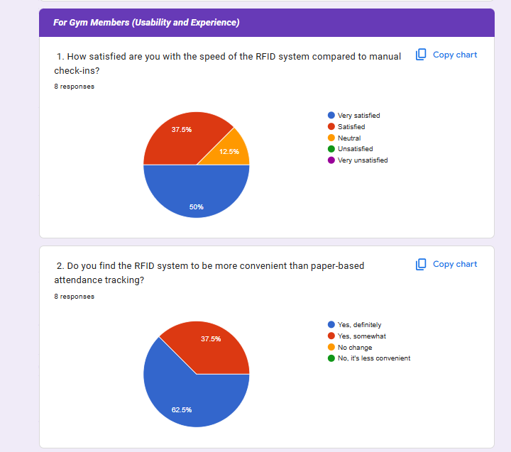
3. Ease of Replacing or Updating RFID Card
Most respondents found the process of replacing or updating their RFID card to be easy.
- 37.5% rated it as Very Easy
- 50% rated it as Easy
- 12.5% selected Neutral
- 0% selected Difficult or Very difficult

This means 87.5% of respondents consider the process easy, indicating that the gym has an efficient and user-friendly card replacement procedure.

4. Impact on Streamlining and Efficiency of Gym Experience
All respondents believe that the RFID system improves their overall gym experience.
- 50% said Yes, significantly
- 50% said Yes, somewhat
- 0% selected No change or Less efficient

This shows 100% positive feedback, suggesting that the RFID system effectively streamlines operations and enhances efficiency for gym members.

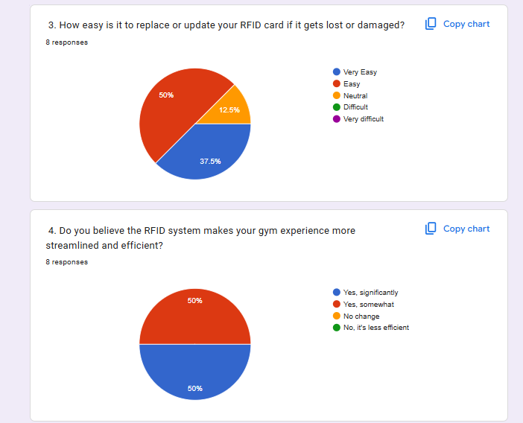

5. Issues with RFID Scanner Hardware
Responses indicate that some members have experienced hardware-related issues.
- 25% experienced issues frequently
- 37.5% experienced issues occasionally
- 37.5% reported no issues

This means 62.5% of respondents have encountered hardware problems at some point, suggesting that scanner reliability may need improvement to ensure smoother operation.

6. Perception of Personal Data Security
Most respondents feel that their personal data is secure with the RFID system.
- 75% rated it as Very secure
- 12.5% rated it as Somewhat secure
- 12.5% selected Not sure
- 0% selected Not secure

This shows that 87.5% of respondents feel confident about data security, indicating strong trust in the system’s protection of personal information.

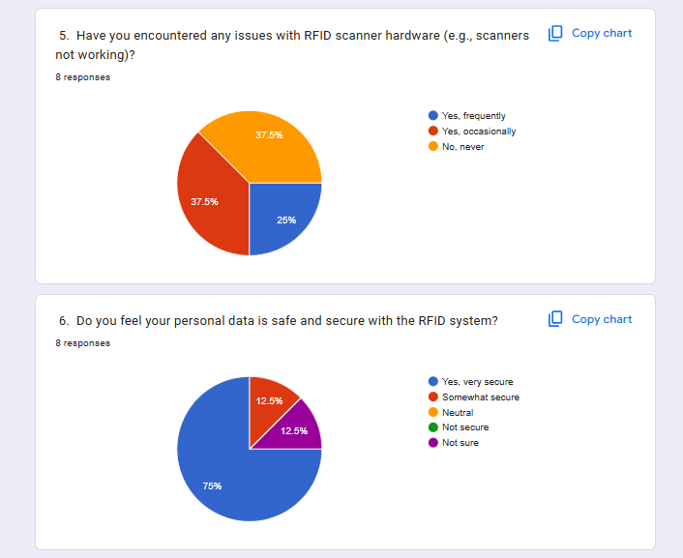

7. Interest in Adding More Features to the RFID System
Most respondents would like to see additional features added to the RFID system.
- 75% selected Yes
- 25% selected Maybe
- 0% selected No

This indicates strong interest in enhancing the system with new features such as workout progress tracking or feedback options, showing that members are open to further development and improvements.

8. Frequency of Forgetting RFID Card for Check-in
Responses show varying levels of forgetfulness among members.
- 25% said Never
- 37.5% said Rarely
- 12.5% said Occasionally
- 12.5% said Frequently
- 12.5% said Always

While most members rarely or never forget their card (62.5%), a small portion forget it frequently or always (25%), which may suggest the need for alternative check-in options such as a mobile-based RFID system.

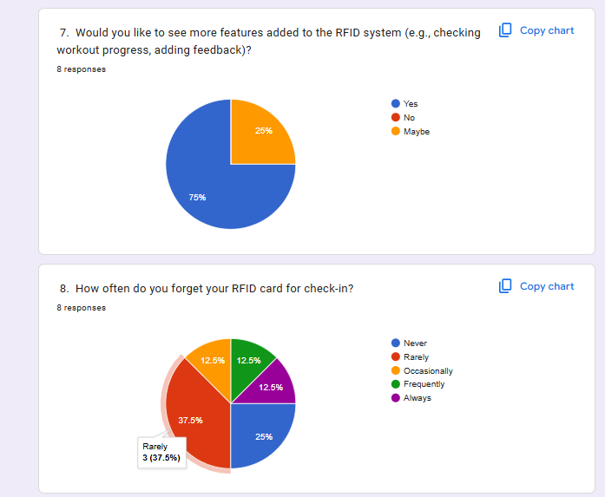
9. Availability of Alternative Check-in When RFID Card is Forgotten
Most respondents indicated that the gym provides an alternative method for check-in if they forget their RFID card.
- 50% selected Yes, always
- 37.5% selected Yes, sometimes
- 12.5% selected No, never

This means that 87.5% of respondents have access to an alternative check-in method at least sometimes, showing that the gym generally accommodates members who forget their cards. However, the small percentage reporting no alternative suggests there may be some inconsistency in implementation.

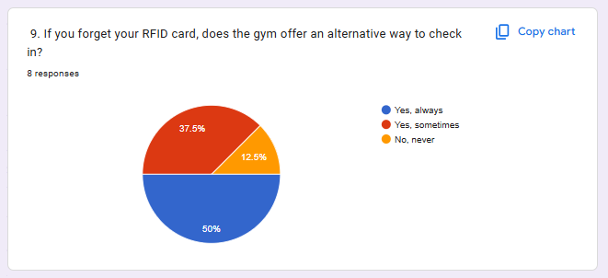

1. Additional Features Members Would Like to See
The responses suggest a mix of suggestions and neutral feedback. Some members proposed technological enhancements, while others felt no additional features were necessary.
Suggested improvements include:
- Iris scan
- Face recognition
- Making the system more accurate and faster
- Improving ease of use

However, several responses such as “none,” “clear,” “ok,” and “.” indicate that some members are already satisfied with the current system and do not see a strong need for additional features.

Overall, while the system is generally well-received, there is interest in incorporating advanced biometric features and further improving speed and accuracy.

2. Importance of a Mobile App Integrated with RFID
All respondents consider having a mobile app important for managing gym attendance and workouts.
- 50% rated it as Very Important
- 50% rated it as Important
- 0% selected Neutral, Not Important, or Not Sure

This shows 100% positive interest in developing a mobile application integrated with the RFID system, indicating strong demand for digital convenience and better workout management features.

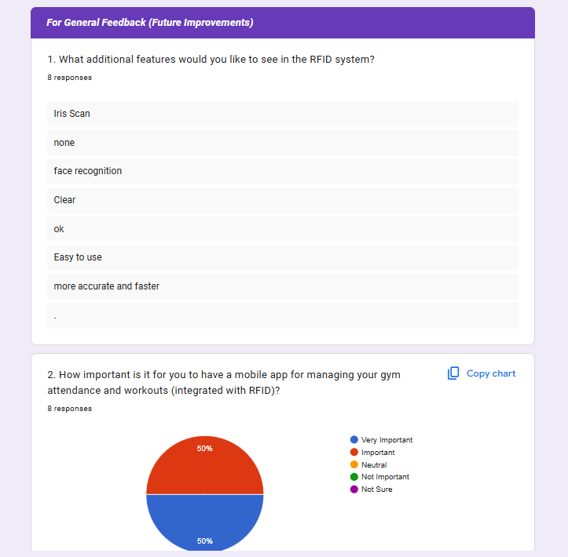

3. Features for Tracking Workout Progress or Real-Time Facility Updates
The majority of respondents support adding advanced tracking features to the RFID system.
- 87.5% selected Yes
- 12.5% selected Maybe
- 0% selected No

This shows very strong interest in integrating features such as workout progress tracking and real-time facility updates. Members clearly prefer a more interactive and informative system.

4. Preference for a Biometric System Instead of RFID
Most respondents are open to using a biometric system instead of RFID for check-ins.
- 62.5% selected Yes
- 25% selected No
- 12.5% selected Maybe

This indicates that while the majority are willing to switch to biometric methods (e.g., fingerprint or facial recognition), a quarter of respondents prefer to keep the existing RFID system. This suggests that any transition should be carefully planned to ensure user comfort and acceptance.

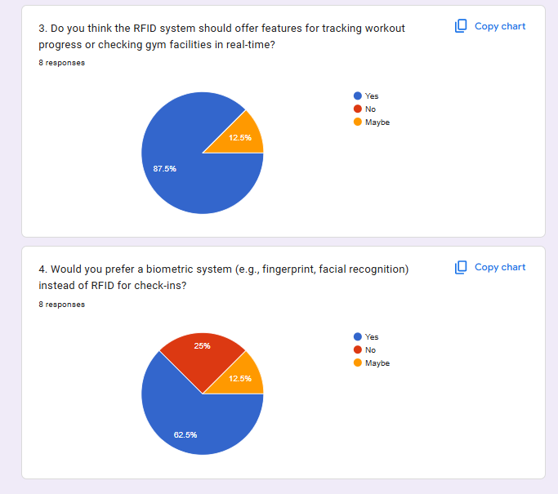

Summary

Chapter 4 discussed the implementation and results of the gym management system with RFID attendance integration. The chapter explained how the system was implemented using RFID technology, ESP32 microcontroller, and a web based system.

The system interface design, RFID attendance testing, and user evaluation results were also presented. The results show that the system functions as intended and is able to record attendance automatically. Overall, the findings indicate that the system is suitable for use in gym operations and supports efficient attendance management.

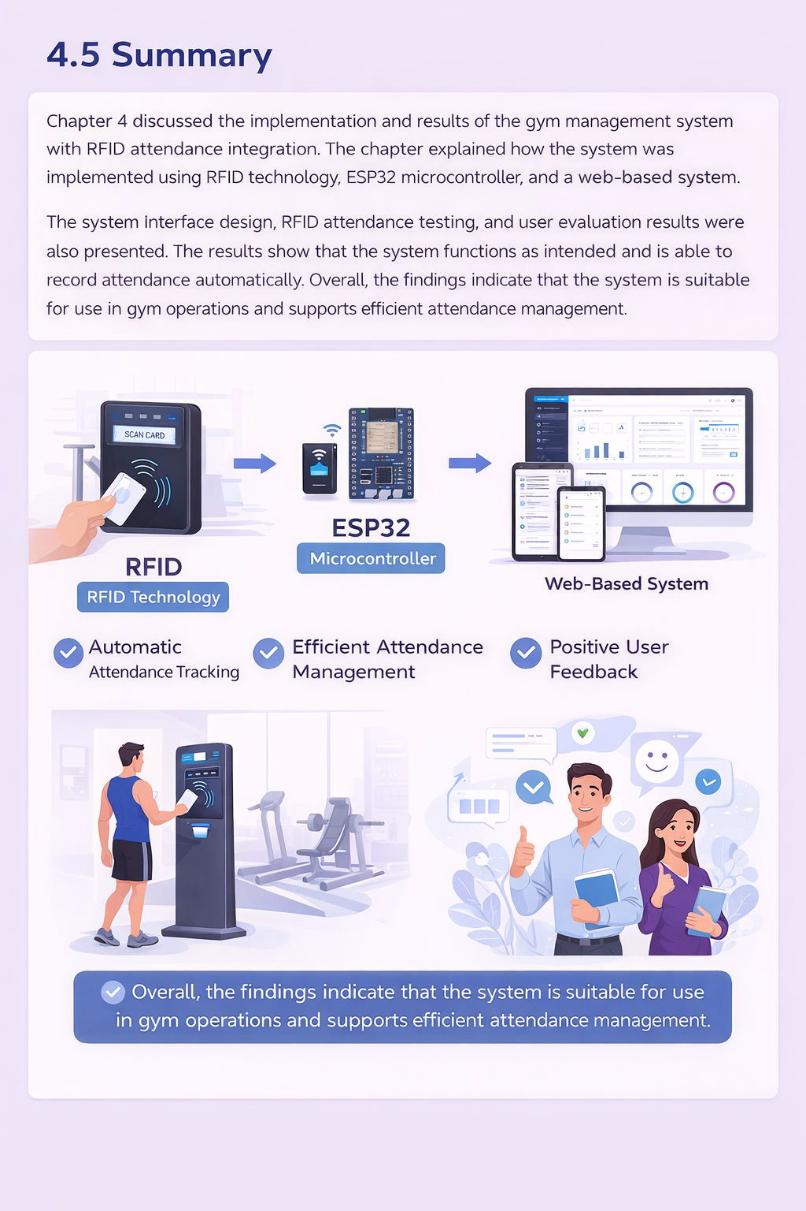

CHAPTER 5: CONCLUSION AND FUTURE WORK

Conclusion

This project focused on the development of a gym management system with RFID attendance integration. The main objective of the project was to automate the attendance recording process for gym members and trainers using RFID technology and a web-based system.

The system was successfully developed using an RFID reader, ESP32 microcontroller, and a web-based application connected to a database. The RFID attendance process allows users to record attendance automatically by scanning RFID cards, reducing the need for manual attendance recording by gym staff.

System testing showed that the RFID attendance function works properly and attendance data can be stored accurately in the database. The system interface is simple and easy to use, allowing administrators to manage users and view attendance records efficiently.

Overall, the project objectives were achieved, and the developed system is suitable for use in a gym environment to support basic attendance management.

Future Improvements

Based on the feedback received from the project assessment session conducted by Dr. Chen on 14 January 2026, several improvements can be considered for future development of the system.

First, the check in and check out logic can be improved to ensure more accurate attendance records. Improving this logic will help reduce issues such as duplicate scans and unclear attendance status.

Second, RFID technology can be expanded for additional purposes beyond attendance recording. In the future, RFID can be used for functions such as access control, equipment usage tracking, or membership verification.

Third, system responsiveness can be improved to provide a better user experience. Faster system response will be beneficial, especially during peak hours when many users are accessing the system at the same time.

In addition, the system can be further developed into a mobile application. Using a cross- platform framework such as Flutter would allow the system to be used on different platforms, including Android and iOS, with a single codebase.

Finally, to enable the system to be used in an industry environment, the core system functions can be further enhanced. Improvements in system stability, performance, and security are needed to meet real-world industry requirements.

Summary

This chapter concluded the project and discussed possible future improvements for the gym management system with RFID attendance integration. The conclusion highlights the success of the project, while the future work section outlines areas that can be enhanced for further development.

REFERENCES

Finkenzeller, K. (2010). RFID Handbook: Fundamentals and Applications in Contactless Smart Cards, Radio Frequency Identification and Near-Field Communication (3rd ed.). Wiley.

• 2. Want, R. (2006). An introduction to RFID technology. IEEE Pervasive Computing, 5(1), 25–33. https://doi.org/10.1109/MPRV.2006.2

Ahuja, S., & Potti, P. (2010). An introduction to RFID technology. Communications and Network, 2(3), 183–186.

Bhuvaneswari, P. T., & Porkodi, R. (2014). The role of RFID in automated attendance systems. International Journal of Advanced Research in Computer Science, 5(2), 95–98.

5. Laudon, K. C., & Laudon, J. P. (2020). Management Information Systems: Managing the Digital Firm (16th ed.). Pearson.

APPENDIX

Appendix A: Google Form Question

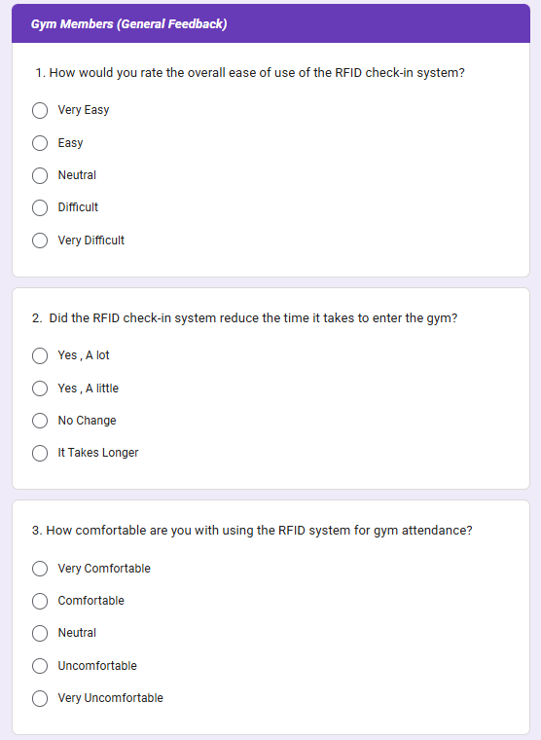

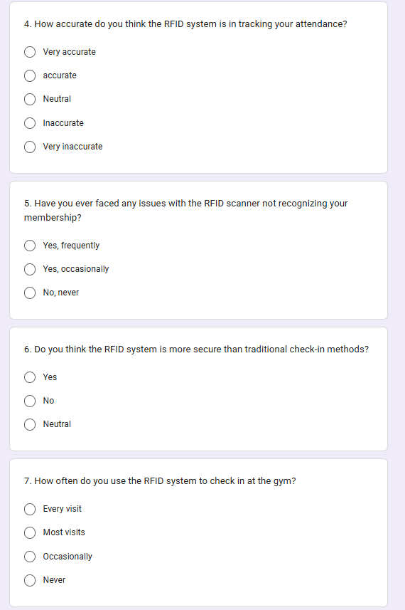

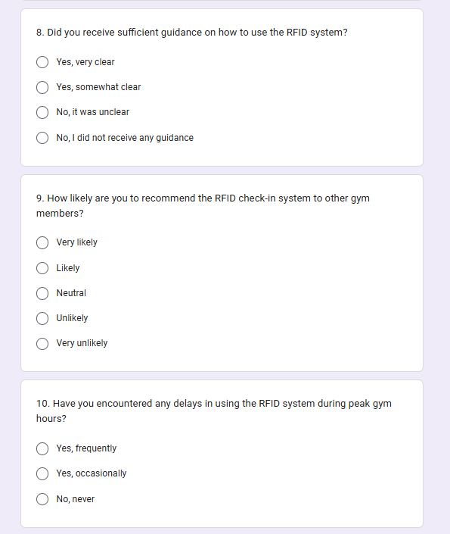

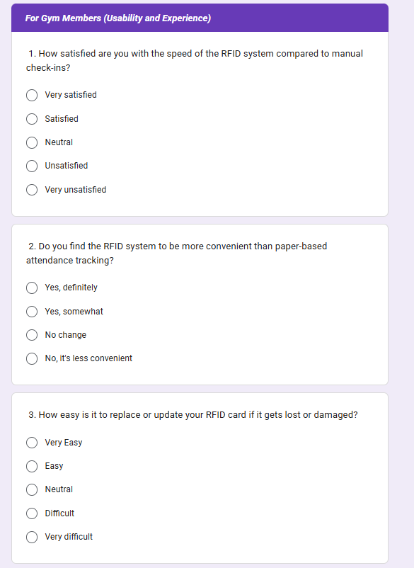

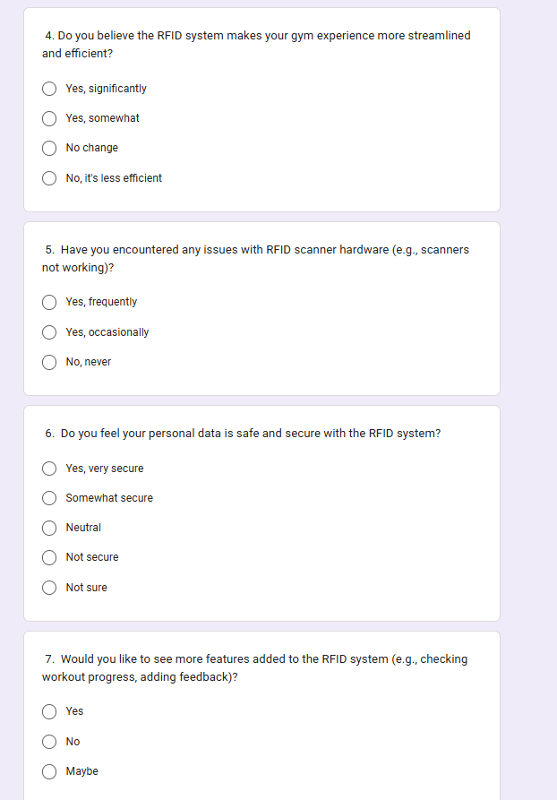

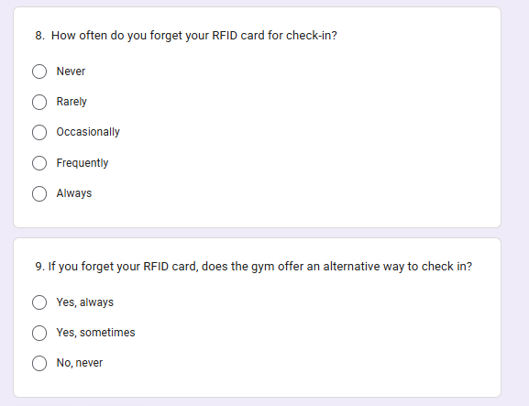

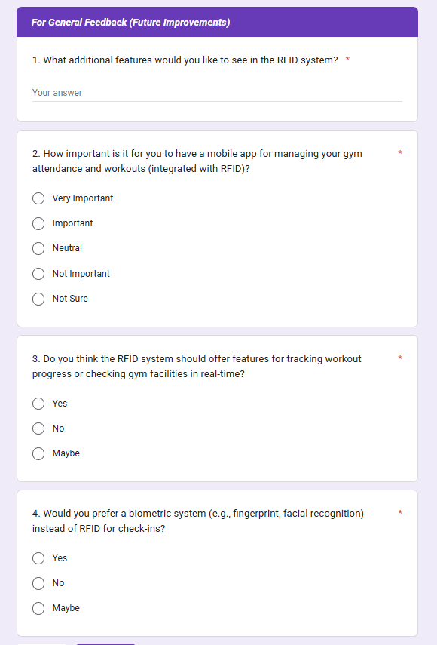

Appendix B: Sample Source Code

1) db.php (connection DB)



2) login.php

(a) function clean + verify hash



(b) POST login + session + redirect by role



3) Admin protect page “admin_dashboard.php”



4) Admin assign RFID (member) — admin_assign_rfid.php



5) Admin assign RFID (trainer) — admin_assign_rfid_trainer.php



6) RFID API - rfid_unified_attendance_api.php











